# User management System HLD Documentation

1. **Objective**

To develop a secure and scalable User Management System supporting role-based access control (RBAC), authentication (login/logout), and authorization (resource permissions). This will implement customer registration email notification and group and permissions.

1. **Architecture Overview**

* **Frontend**: React / Angular / Vue (depending on tech stack)
* **Backend**: RESTful API (Node.js / Java / Python)
* **Auth Service**: OAuth 2.0 / JWT / SSO
* **Database**: PostgreSQL / MySQL/SQL Server
* **Cache**: Redis (for session management)
* **Integration Tool**: Apache Camel
* **Message Broker** (optional): Kafka (for login/audit events)
* **Notification:** Send notification for registration, forgot password etc

1. **Modules**

* **User Service**: Manage users (CRUD)
* **Role Service**: Define and assign roles
* **Auth Service**: Login, logout, token generation, validation
* **Permission Service**: Assign fine-grained access control
* **Audit Logging**: Track all actions
* **Notification Service**: Email/SMS on actions like password reset, 2FA, etc.

**DFD Level 0**

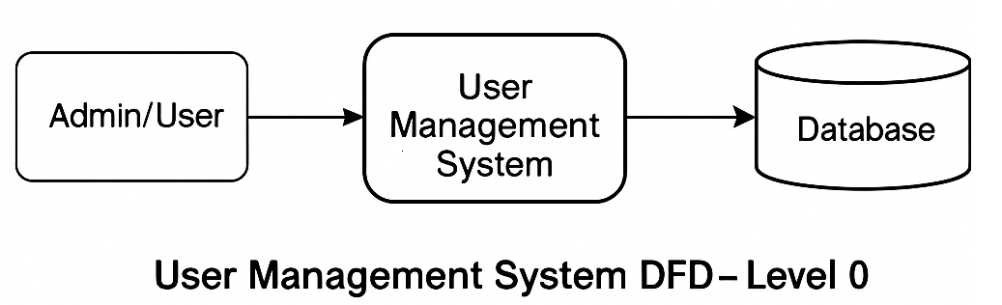

**DFD Level 1**

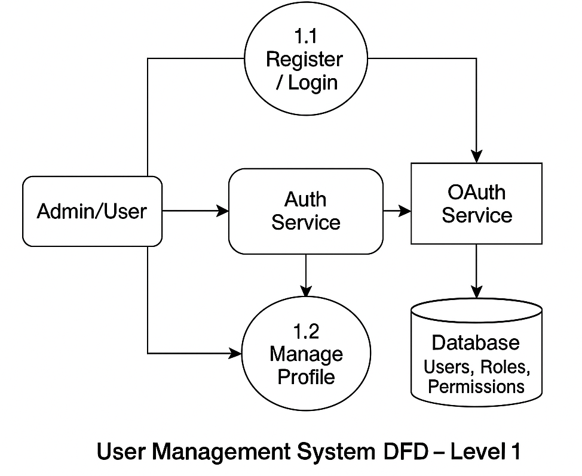

**DFD Level 03**

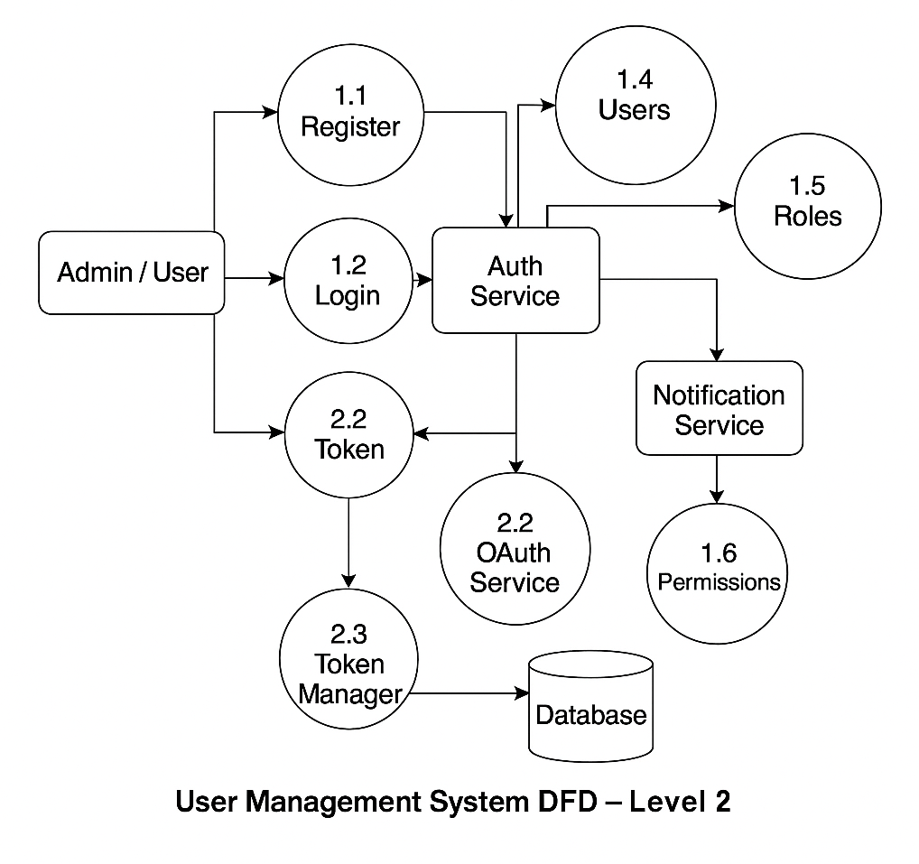

DFD Level 04

